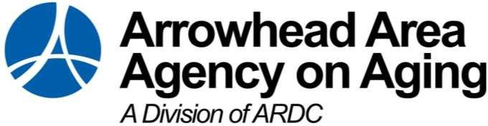

Eldercare Development Partnership Advisory Committee

Enacted in 1992, the Eldercare Development Partnership (EDP) legislation was created to increase the capacity of local long-term care services and resources to support older populations in

Minnesota. The Arrowhead Area Agency on Aging is strategic with public and private entities and Long-Term Services and Support (LTSS) providers to collaboratively develop systems change.

The EDP Advisory Committee provides guidance, resources, and feedback regarding the agency’s work plan implementation and progress.

The EDP Advisory Committee will establish a purpose and structure around informed development work and grant-making opportunities.

The Advisory Committee will assist with recruiting membership for the EDP Advisory Committee by recommending staff and other relevant parties that should be involved. Duties also include providing feedback on the EDP plan.

Ultimately, the committee will share some responsibility in implementing and evaluating the goals, objectives, and strategies outlined in the EDP plan.

The goals and objectives of this Committee shall include, but not be limited to the following:

1. To assist the AAAA in the development and implementation of the EDP plan to meet the needs of older persons based on the needs of older populations.
2. To stimulate local governments and agency planning.
3. To represent the needs of residents, agencies, and local governments in areawide plans.
4. To assist in the identification and determination of needs, problems, and issues in the region based on the needs of older populations.
5. To identify goals and priorities of the Arrowhead Area Agency on Aging EDP work.
6. To ensure that issues unique to areas are studied and understood.
7. To translate broad statewide planning guidelines in terms of the needs of local areas.
8. To provide public relations for regional, state, and federal planning efforts directed to the issues of older persons.
9. Advocate for gap services for older population.